**Mathematics in the 21st Century**

**Lecture Five: The art of maths**

**Chris Budd OBE, University of Bath, UK**

**Gresham Professor of Geometry**

March 10th, 2020

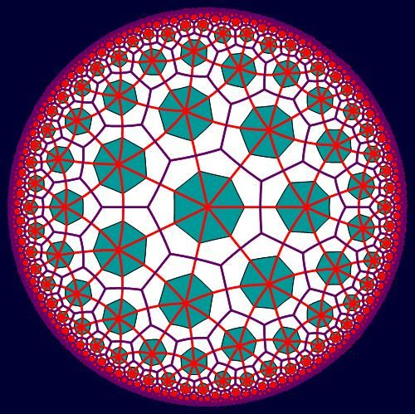

**1. Introduction**

Maths and art have much in common. Both are intensely creative, both have a strong abstract nature, both are highly creative, and both are driven by the search for beauty. An often asked question is whether maths is and art or a science. In practice it shares aspects of both, and it is a shame that the more ‘artistic’ aspects of maths are often not emphasised more in the way that maths is taught. (If it was I am convinced that many more young people would appreciate the creative side of mathematics). Whole conferences, such as the Bridges Conference [??] and the Origami Society for Mathematics, are devoted to the role of mathematics. Mathematics has been involved with art from the earliest days, from the Sona diagrams from sub Saharan Africa, to the perspective of the Renaissance, and from Islamic geometrical designs, to the wonderful work of Escher. Indeed, we all experience the interplay between mathematics and art in our lives, whether it is in the pattern of the wallpaper on our walls, or the style of our favourite knitted jumper.

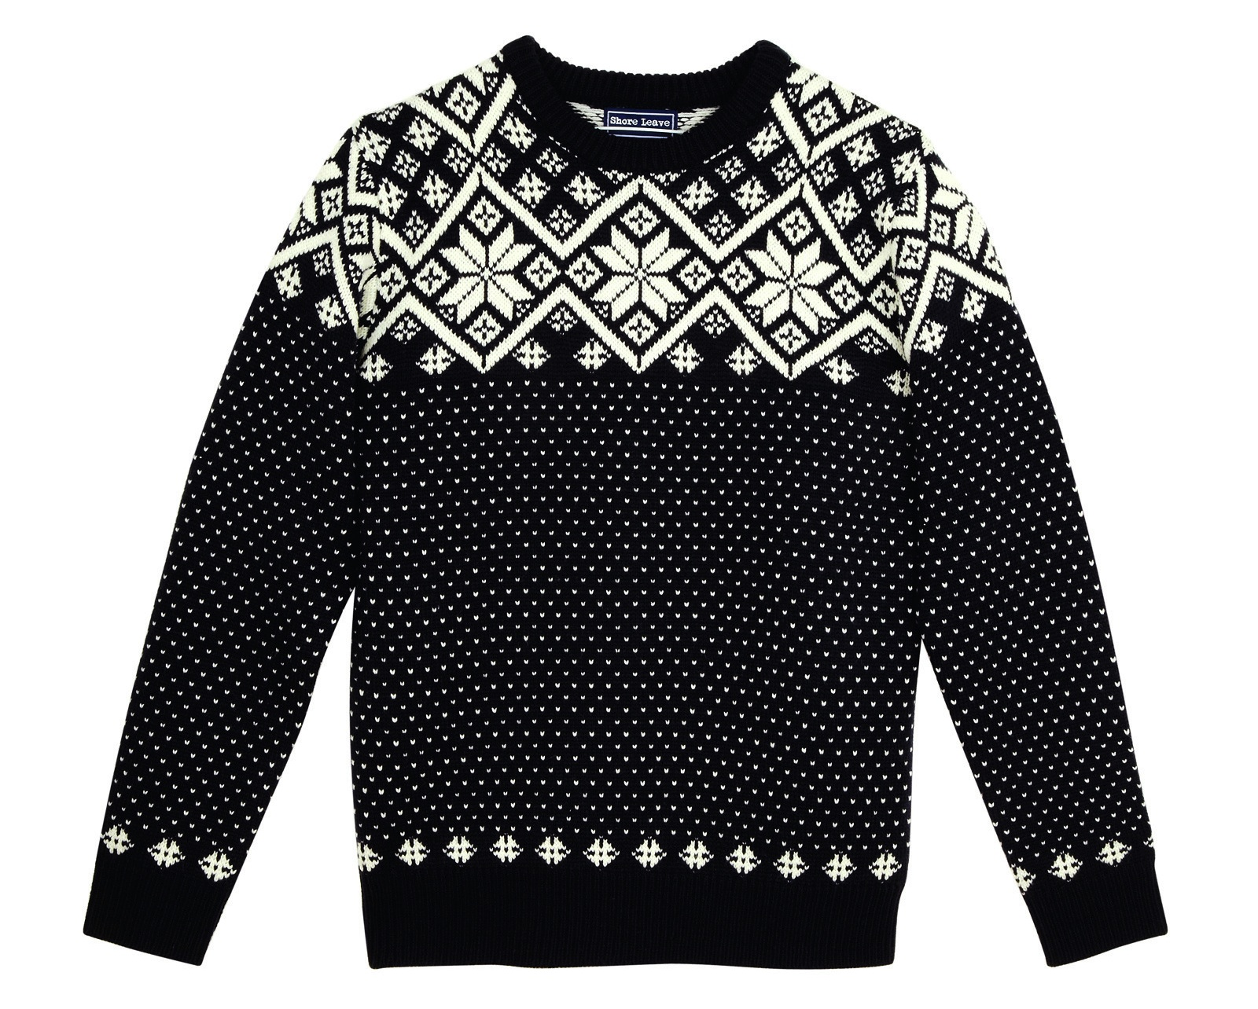

In this lecture we will take a look at many of the aspects of mathematical art mentioned above. We will also conclude the lecture with a little bit of mathematically inspired dancing (which you will have to do at home if you are reading this transcript). I hope that at the end of it, you will truly appreciate what a creative, and beautiful subject, that mathematics really is!

**2. Celtic and Sub-Saharan African Art**

**2.1 Celtic Art**

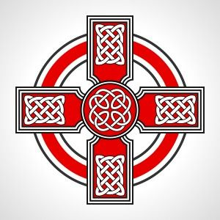

One of the earliest examples of geometrically inspired art comes from the Celtic artistic tradition, especially the drawing of Celtic Knots. This tradition dates back to ???? both as a popular art form, and also through the illustration of sacred texts in monasteries and churches. These designs look extremely intricate, and indeed took a long time to create by the monks, but they are all based on sound mathematical principles. Once these principles are mastered, not only can you recreate the original Celtic designs, you can also design your own. Even if you have no artistic talent.

**< Bit more on the history here >**

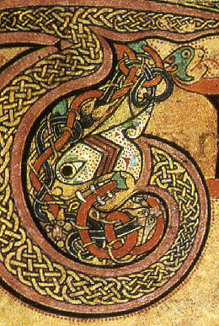

Below we can see the letter T from the title page of John’s Gospel in the celebrated *Book of Kells.* This masterpiece was written at around 800AD in Ireland and is an early version of the Gospels. It was richly illustrated, as can be seen below. It is not quite clear what the illustrated animal is, with various theories ranging from a snake to a lion, neither animal being native to Ireland. What is of main interest to us is the art work inside the animal, which is a nice example of a Celtic Knot.

The designs seen in Celtic Art very often take the form of knots, or links. A *knot* is a design formed from one piece of string, usually with its ends joined together. A *link* is a design made up of several pieces of string, again with their ends joined together. The general theory of knots is a rich (and difficult) are of modern mathematics. Examples of knots are given below, with the complexity of the knot increasing with the number of crossings. The knot with three crossings is often called the *trefoil knot* and is a frequent image in both Celtic art and the art of many other cultures. One reason for this is that it is the simplest knot which cannot be untied. The familiar reef knot, often used to tie two pieces of strong together, is just two trefoil knots added together. Below is a lovely sculpture of a trefoil knot by John Robinson at Bangor University. The other knots with a small number of crossings (up to five) have a pleasing symmetry, which leads to them also being f0und in a lot of Celtic art. After that the general knot design becomes more complex and is less often seen in art. One of the most challenging problems in mathematics involves classifying all of the possible types of knot with a given number of crossings.

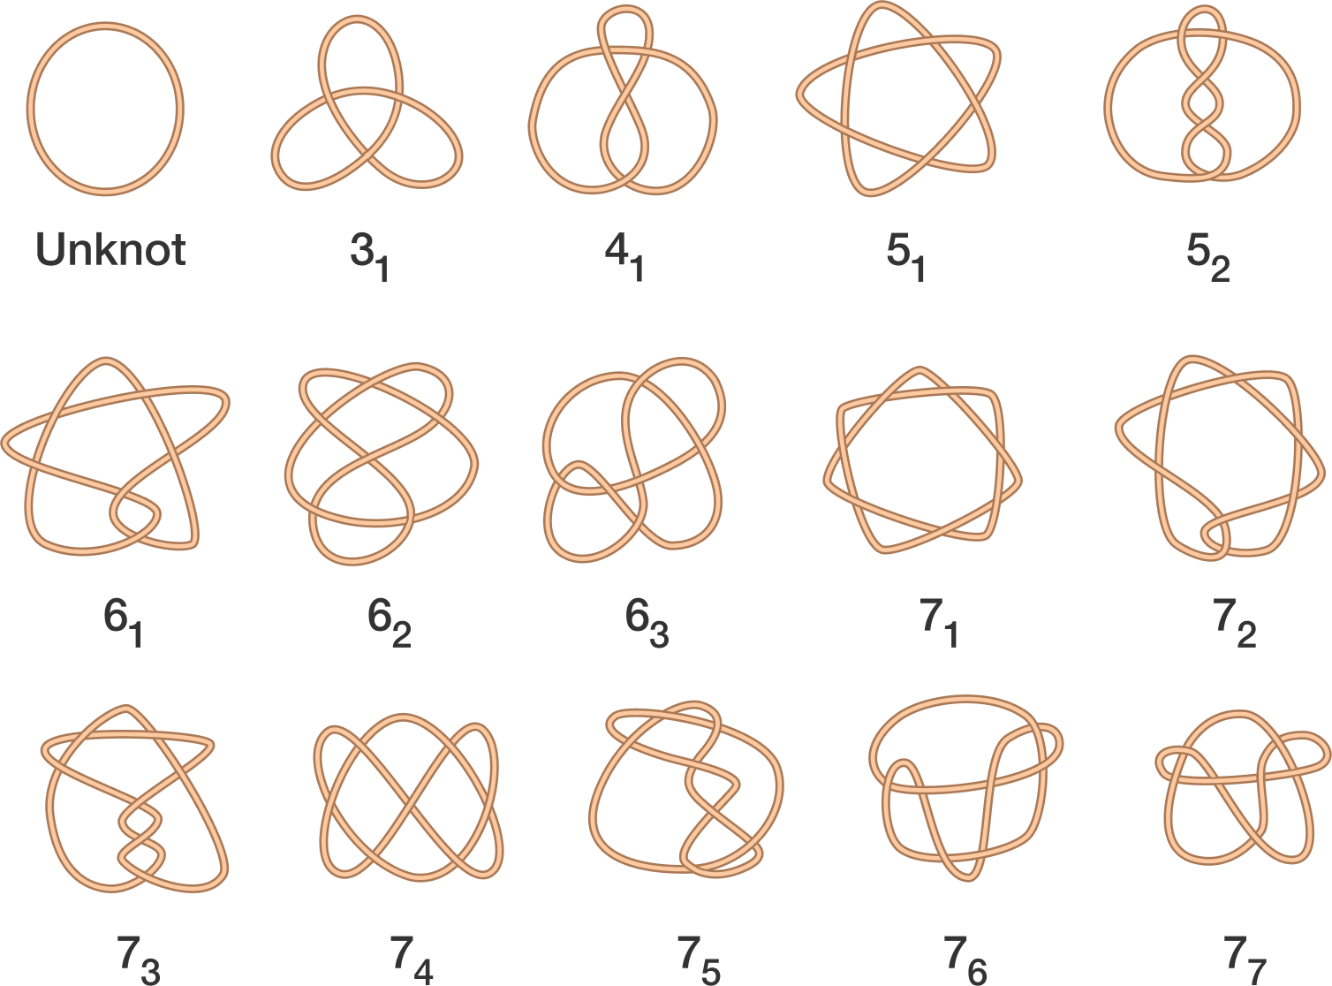

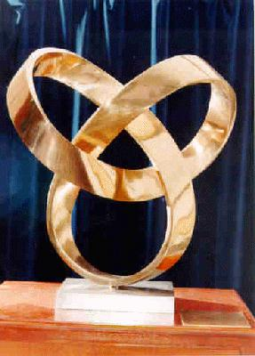

The most common form of knot observed in Celtic art is the ‘under and over’, or alternating, knot. In this design the ‘string’ alternates between passing above, and then below, the others . An example of a link, which takes this form, is given below. This link is made up of four different intertwined loops. The under and over design both looks good, and reduces the number of possible types of knot with a given number of crossings.

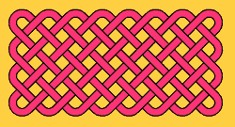

One way to construct a (relatively simple) under and over knot is to start with a grid of squares:

|  |  |  |
| --- | --- | --- |
|  |  |  |
|  |  |  |
|  |  |  |
|  |  |  |

Any grid will do. We will give the grid a classification **(m,n)** which means that it is made up of m vertical lines and n horizontal lines. Different values of m and n lead to different types of knot or link. The above is a (5,4) grid. Below is a (6,5) grid. The knot/link on this grid is started by placing crosses on the horizontal mid-points as indicated. Note the direction of the over and under crosses.

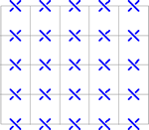

The next stage is to place crosses on the vertical lines, with the under and over crosses going the other way.

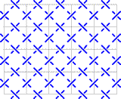

Finally you join up the crosses, with right angle turns at the sides and U-turns at the corners.

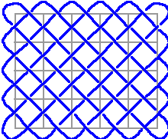

The result is either a knot or a link. What you get depends on the type of grid that you use. The patterns that arise closely resemble fishing nets, and we can count the number of pieces of string that are needed to make them. There is close link between the number of pieces of strong and the form of the grid. Here are some examples:

|  |  |  |
| --- | --- | --- |
| **m** | **n** | **Number of strings** |
| **5** | **6** | **1** |
| **2** | **2** | **2** |
| **3** | **4** | **1** |
| **3** | **6** | **3** |
| **4** | **4** | **4** |

It is an interesting challenge to find a rule which links the pair (m,n) to the number of strings. Doing this is a useful introduction to how maths can be done (at least this is the way that I, and many others, do it). I would describe this as follows:

1. Do lots of experiments
2. Look for patterns
3. Make a hypothesis
4. Check your hypothesis with lots of other examples
5. Prove your result using mathematical reasoning.

The first four of these represent the scientific method. It is number 5 which distinguishes mathematics from science. Many of my mathematical colleagues also omit item 1 on this list.

After some experiments you should some up with the hypothesis that the number of strings are given by the **greatest common divisor of the two numbers m and n, gcd(m,n).** Which is the largest number which divides both m and n. So gcd(2,7) = 1 and gcd(2,8) = 2. It really does work, and you can test it (by drawing) on many examples.

Proving this result is actually quite hard. You do it by successively reducing the size of the problem, whilst keeping the same number of strings. The proof is actually a geometrical version of the celebrated Euclidean Algorithm for finding gcd(m,n). This is one of the first recorded algorithms, and was described in Euclid’s elements in 300BC. It is still in use today, in areas such as cryotograpy, error correcting codes and predicting eclipses. Euclid’s algorithm uses the fact that

gcd(m,n) = gcd(m,n-m)

or in other words the number of pieces in an (m,n) grid is the same as in an (m,n-m) grid. Try showing this yourself.

True Celtic art of course uses much more complex patterns than those described above. Here is an example

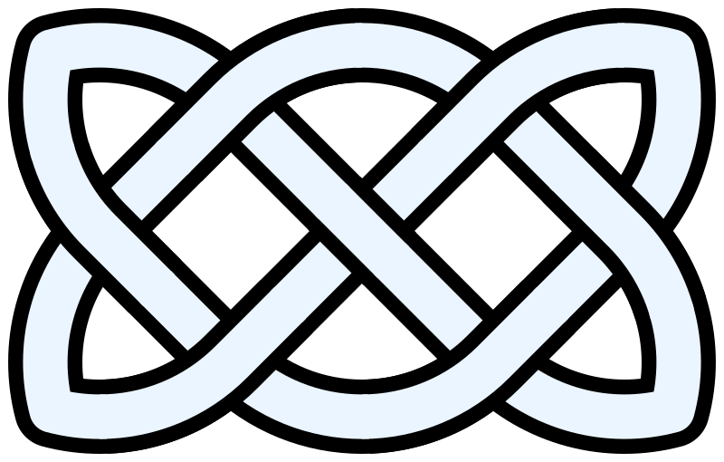

Despite looking complex, most of these designs can be constructed by using a succession of simple rules. See below for a guide to how to do this..



Different knots can be created by taking different grids (even circular grids will work, or even grids in the tail of a snake) and by choosing different combinations of the knot crossing designs A,B and C for the corners. The knot above is an AAA design. In fact for a grid as above we can make an algebra of 27 knots by looking at the different types of arrangement. For example AAA, AAB, AAC, ABA, .. all give different knots. Once the arrangement has been decided, drawing the knot is straightforward. Try it for yourself. It is easy to go from a mathematical arrangement to a beautiful Celtic knot design

**2.2 Plaited Mat Sona Art**

The Sona art traditions of sub-Saharan African art predates Celtic art, and produces striking patterns of great complexity and power, which have similar mathematical structures to the Celtic patterns. Sona patterns are mainly found in Angola and Mozambique, and are traditionally drawn with fingers in the sand. These patterns are beautifully described, and their mathematical properties studied, in the wonderful book [??].

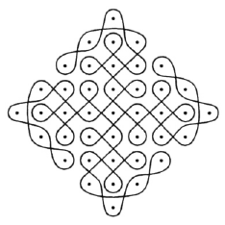

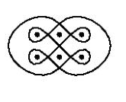

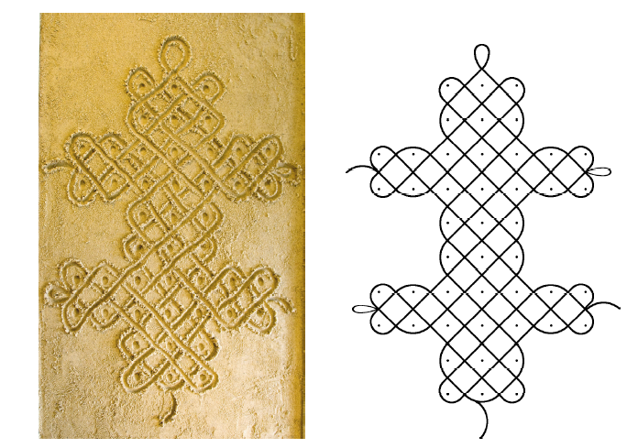

**Basic Sona Plaited Mat Patterns**

The Tchokwe people of south-central Africa have a tradition of storytelling using Sona, as memory aids. Typically these drawings would be traced in the sand winding around a rectangular grid of finger dots, again by using a finger, while telling the tale. Ideally the entire figure would be traced without having to remove the finger from the sand so that the entire diagram is constructed with a single curve that does not retrace itself. This is called a mono-linear curve. One of the simplest types of Sona is called the plaited mat design. This starts with a regular, rectangular, pattern of dots. Then a curve is drawn at 45 degrees to these dots. The edge of the rectangular grid then behaves like a mirror with lines hitting the mirror and rebounding at 45o . At the corners, the curve does (another) U-Turn. Here are two examples:

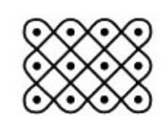

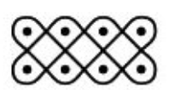

Just as in the case of the Celtic Knot patterns we can classify the plaited mat designs by the two-dimensional arrangement (m,n) of the dots. On the left is a (3,4) design, and on the right a (2,4) design. We can then ask the question of how many times we have to trace over the figure to get the design (that is how many times we have to list off our figure when doing the drawing). In fact we already know the answer. The number of loops L that we need is (as before)

L = gcd(m,n).

Thus we get the desired mono-linear design if gcd(m,n) = 1, so that m and n are *co-prime*.

The pictures above also show a high degree of symmetry, which is one reason that they have such a beautiful form.

**Lion’s stomach**

There are many examples of different, and more complex, Sona patterns, which display a high degree of symmetry. Below is the Lion’s stomach design.

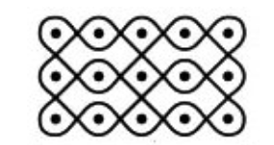

**Chased Chicken**

Another design (in fact my personal favourite) is the Chased Chicken design.

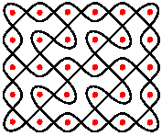

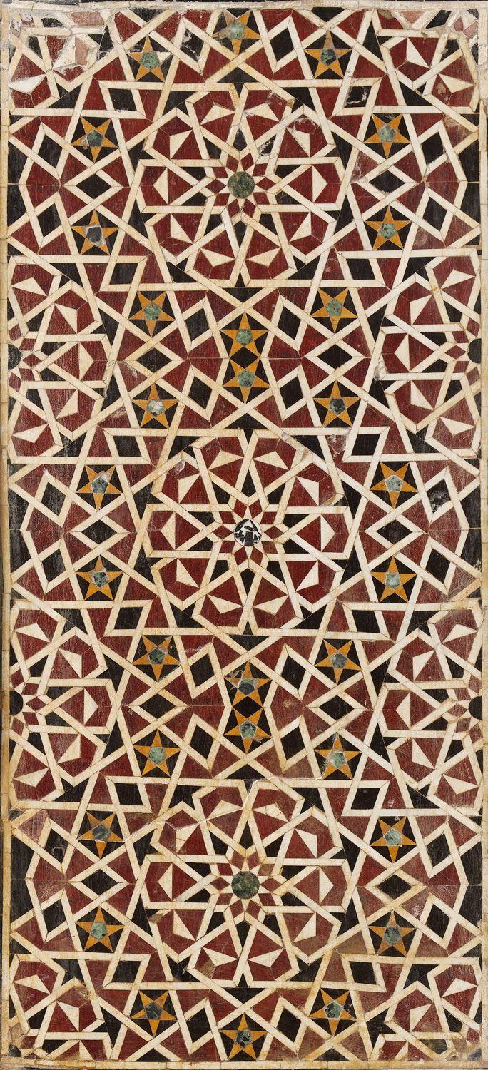**3. Islamic art, wallpaper, tilings, and quilt patterns**

In contrast to sub Saharan Africa, the North of Africa, in particular those countries associated with the Islamic faith, give a very different, and a very lovely, example of mathematically inspired art. The Islamic faith was founded in ??? and provided laws to govern both religious observance and also social behaviour. While the Qur'an contains no specific prohibition on making images of people or animals, most interpretations of the Islamic law have tended to discourage any such imagery as potentially idolatrous, leading from an exclusion of these from most religious settings. As a result, Islamic art developed in the directions of abstraction and geometry, with the result being some very beautiful, geometrically inspired, patterns. This use of geometry is also thought to reflect the language of the universe (which is true of course) and help the believer to reflect on life and the greatness of creation.

These geometrical patterns have now been developed (often by mathematicians) into tiling patterns and patterns on quilts, and we will have a look at all of these in this section.

**3.1 Geometry in Islamic design**

Here are some excellent examples of Islamic art.

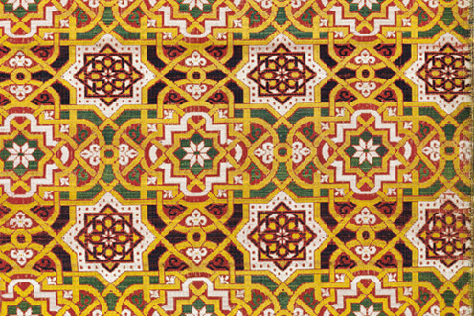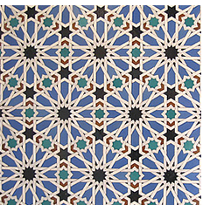

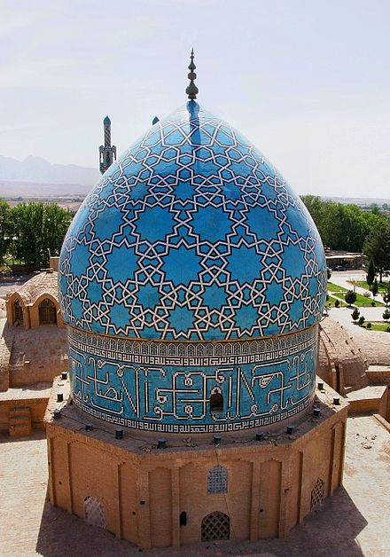

(The Shah Nematollah Vali Shrine. This combines 5,7,9,12,11,9 and 10 points in turn.)

Among the most important aspects of Islamic geometric design are repetition and variation. A series of tiles, for example, may consist of only one or two basic shapes but the patterns of the tiles may all be different and the shapes are then combined to create a complex interlocking pattern. Examples of some of the repeated designs are given below. They are frequently constructed by using the ruler and compass constructions, used by the Greeks as a foundation of their geometry

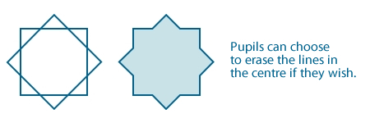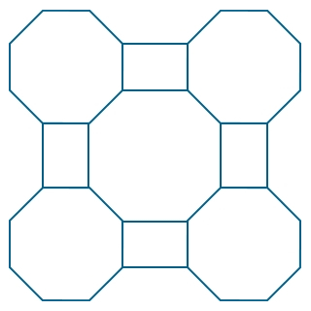

Further information on both the history of Islamic art, and how to use a ruler and compass to construct the designs is given in the article [??] by Alex Bellos.

Symmetry also plays a part in most Islamic patterns. There may be a single line of reflexion symmetry, usually from the top to the bottom, or there may be three or four lines of symmetry. Translational and rotational symmetry are also used, and are frequently combined in the same design.

This leads us naturally to the concept of a Euclidean symmetry E2, which are the transformations of the plane which preserves distances. So that if x is a point in the plane then g(x) is where it ends up after the action of the symmetry. Euclidean symmetries are either

Translations: g(x) = a + x

Reflexions: g(x) = -x

Rotations: g(x) = Mx where M is a *rotation matrix*

Or a combination of these.



An Islamic art pattern is a special case of a *Wallpaper Pattern*. An example of one of these is given below.

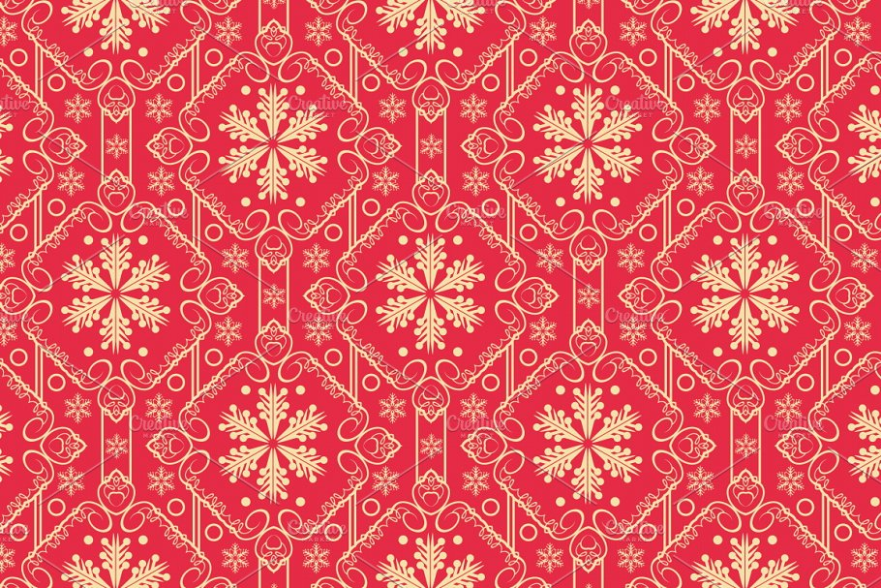

A wallpaper pattern is simply a repeating pattern on the plane, which is unchanged under the action of some of the Euclidean symmetries, such as a rotation or a translation in some direction. A *wallpaper group* is a subgroup of E2 which leaves that wallpaper pattern unchanged.

Remarkably, it was shown in 1891 that there are exactly **17 types of wallpaper group**. Of these five are typically seen in Islamic art. The basic types are seen below, taken from [??].

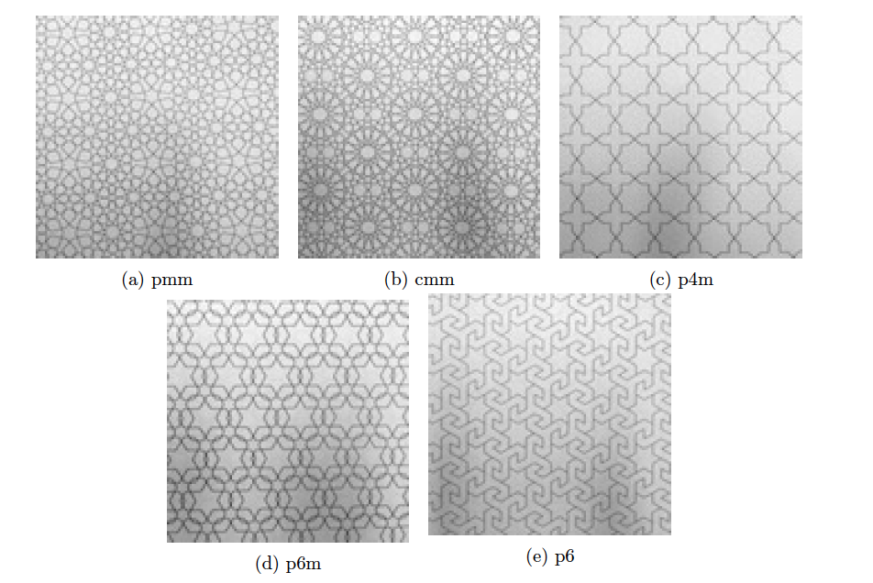

Examples of wallpaper patterns for each of the 17 wallpaper groups (taken from [??]) are given below

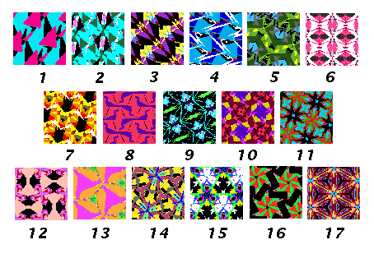

**3.2 Tilings and tesselations**

A tiling is closely related to a wallpaper pattern, and is a regular arrangement of shapes on the plane. An example of a tiling drawn by Escher (see later) is *Reptiles* which he created in 1943. Remarkably this pattern shows the same reptile shape repeated across the plane in such a way that the pieces perfectly fit together.

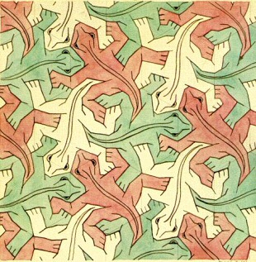

One feature of this figure is that it is very regular, with the red (or green,or yellow) reptile repeating its position periodically. Most tilings are periodic. However, not all. Important example of aperiodic tilings are Penrose Tilings, which were discovered by the British mathematician Roger Penrose. We will meet him later again. Here is an example of a Penrose tiling. For another visit the mathematics department in the Andrew Wiles building in Oxford.

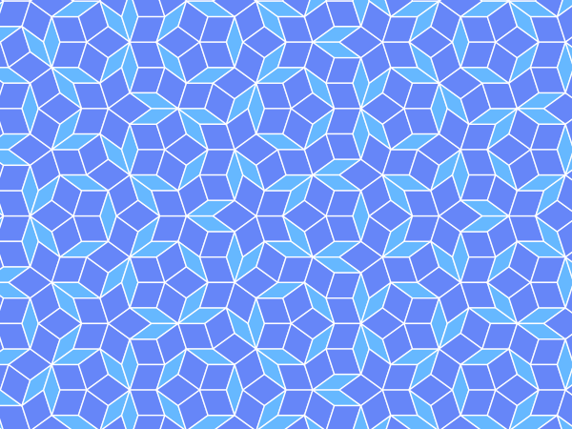

Mathematicians have long studied the ways that we can tile the plane. The result of this work are excellent colouring books [??,??,??]. The question is: how shapes, or *tiles*, can be arranged to fill a plane without any gaps. One such example is a Pythagorean Tiling which is made up of squares of different sizes.

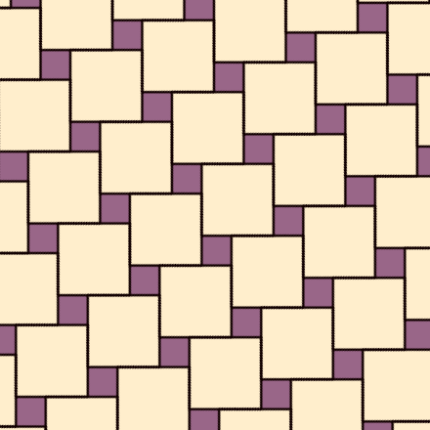

**4. Renaissance art and perspective.**

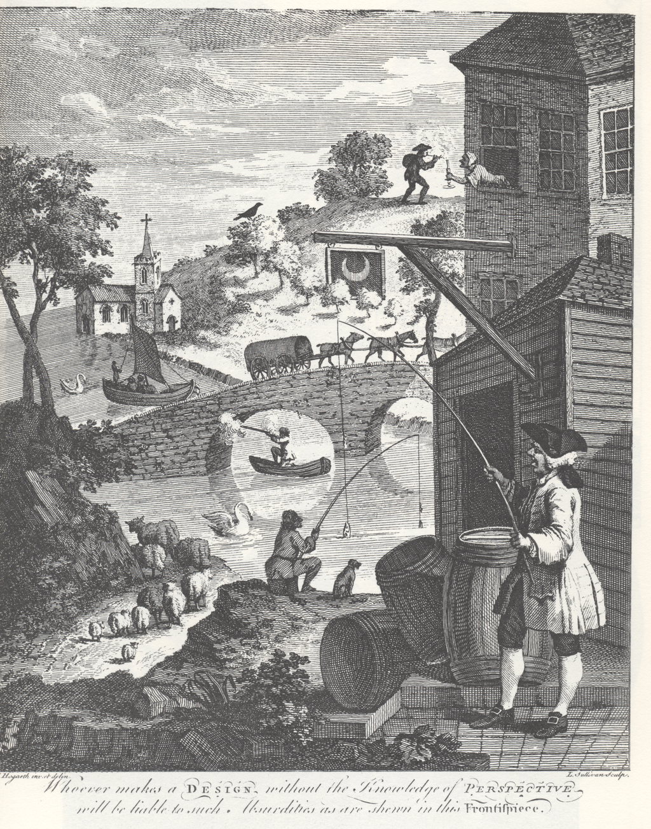

**Projective geometry**

**5. M.C. Escher and Fractals**

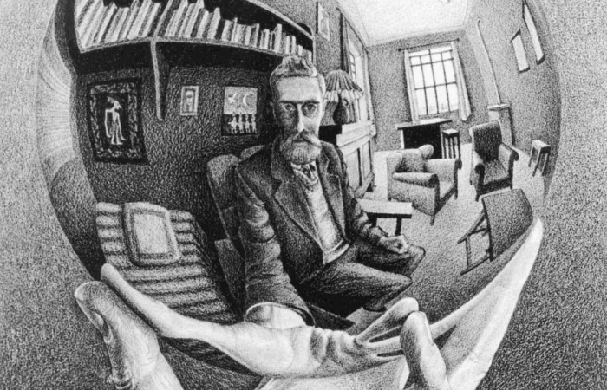

One of the most interesting artists of the 20th Century was M.C. Escher (1898-1972). His pictures are known by nearly everyone. Many of them display a striking mathematical form, in which Escher explores some deep mathematical ideas. A major reason for this is that Escher was strongly influenced by several great mathematicians including, George Polya, Harold Coxeter and also Roger Penrose, who we met in the last section. Further mathematicians have carried on Escher’s great legacy, most especially Hendrik Lenstra from the University of Leiden. His work features mathematical objects and operations including polyhedra, impossible objects, explorations of infinity, symmetry, perspective, hyperbolic geometry, and tessellations. The mathematical basis, and sheer beauty, of his work, which is of course and entirely positive bridge between maths and art, led to Escher to gain a great popular following, greatly enhanced by being featured in the (legendary) Scientific American column written by Martin Gardner. However, it also, sadly, led to the lack of esteem with which he has been viewed in the art world. Indeed we had to reach to 2015 before the first major exhibition of his art was held in the UK (in Edinburgh, and I visited it!). He was, perhaps, an artist more appreciated by mathematicians and the general public, than the art world itself. The links between his work, that of the logician Goedel and and composer Bath are explored in the classic work Goedel, Escher, Bach by Douglas Hoffstadter [??].

*Escher and Coxeter*

We have already seen, in Reptiles, one example of Escher’s explorations of tessellations of the plane. This was a theme that he returned to many times, and in fact did much original research into. Another example is his famous 1938 picture *Day and Night* shown below:

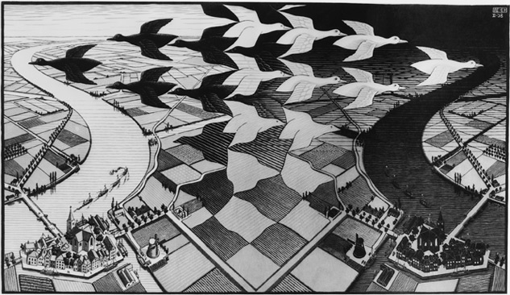

However, Escher, remarkably, was not content just with looking at the plane, but instead looked at ways of tessellating other shapes. One of his most famous pictures, *Angels and Devils*, a woodcut produced in 1960 (when he was 62) is shown below in which we can see the Angels and Devils, tessellating and also becoming denser and denser as they approach app the boundary of the circle.

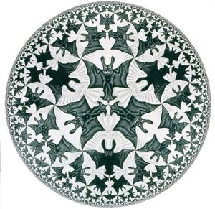

The same pattern can be seen in other examples of his work, and is based on a branch of mathematics called hyperbolic geometry. In fact the origin of this figure came from a mathematics conference! In 1954, the organizing committee for the International Congress of Mathe­maticians (the main mathematics conference in the world, both then and now) promoted an exhibition of Escher’s work at the Stedelijk Museum in Amsterdam. In the companion catalogue for the exhibition, the committee called attention not only to the mathematical substance of Escher’s tessellations but also to their *peculiar charm*. Three years later, the eminent Canadian mathematician H.S.M. Coxeter recalled the exhibition and wrote to Escher, requesting per­mission to use two of his prints as illustrations for the article. On June 21, 1957, Escher responded enthusiastically:

*Not only am I willing to give you full permission to pub­lish reproductions of my regular-flat-fillings, but I am also proud of your interest in them!*

This led Coxeter in 1958 to send Escher a copy of an article he had written which contained the figure below (which Coxeter called Figure 7), which is a non-Euclidean projection of the plane onto the disc.

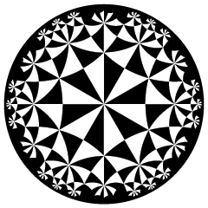

Escher immediately saw the potential in this figure and wrote back to Coxeter:

*Though the text of your article on “Crystal Symmetry and its Generalizations” is much too learned for a simple, self-made plane pattern-man like me, some of the text illustrations and especially Figure 7, gave me quite a shock. Since a long time I am interested in patterns with “motifs” getting smaller and smaller till they reach the limit of infinite smallness. The question is relatively simple if the limit is a point in the centre of a pattern. Also, a line-limit is not new to me, but I was never able to make a pattern in which each “blot” is getting smaller gradually from a centre towards the outside circle-limit, as shows your Figure 7. I tried to find out how this figure was geometrically con­structed, but I succeeded only in finding the centres and the radii of the largest inner circles (see enclosure). If you could give me a simple explanation how to construct the following circles, whose centers approach gradually from the outside till they reach the limit, I should be immensely pleased and very thankful to you! Are there other systems besides this one to reach a circle-limit? Nevertheless I used your model for a large woodcut (CLI), of which I executed only a sector of 120 degrees in wood, which I printed three times. I am sending you a copy of it, together with another little one (Regular Division VI ), illustrating a line-limit case.*

On December 29, 1958, Coxeter replied:

*I am glad you like my Figure 7, and interested that you succeeded in reconstructing so much of the surrounding “skeleton” which serves to locate the centres of the circles. This can be continued in the same manner. For instance, the point that I have marked on your drawing (with a red • on the back of the page) lies on three of your circles with centres 1, 4, 5. These centres therefore lie on a straight line (which I have drawn faintly in red) and the fourth circle through the red point must have its centre on this same red line. In answer to your question “Are there other systems be­sides this one to reach a circle limit?” I say yes, infinitely many! This particular pattern is denoted by {4, 6} because there are 4 white and 4 shaded triangles coming together at some points, 6 and 6 at others. But such patterns {p, q} exist for all greater values of p and q and also for p = 3 and q = 7,8,9,... A different but related pattern, called <<p, q>> is ob­tained by drawing new circles through the “right angle” points, where just 2 white and 2 shaded triangles come together. I enclose a spare copy of <<3, 7>>… If you like this pattern with its alternate triangles and heptagons, you can easily derive from {4, 6} the analogue <<4, 6>>, which consists of squares and hexagons.*

Whilst well meant, this reply was not entirely straightforward and Escher wrote to his son that

*I am so often at cross purposes with those theoretical mathematicians, on a variety of points. In addition, it seems to be very difficult for Coxeter to write intelligibly for a layman.*

True words indeed! However, Escher persevered in getting to grips with Coxeter’s ideas, and the result was some of his finest pictures.

It is well worth saying that much of Escher’s work show striking similarities to fractal patterns. I described these in some detail in by 2018 lecture *Can Maths Predict the Future,* on Chaos Theory. Briefly a fractal is a pattern, which if enlarged, shows the same structure. A phenomenon called self-similarity. Escher’s Angels and Devils picture shows exactly this structure, and it follows because Coxeter’s geometrical ideas were themselves closely related to the mathematics of fractals. Perhaps the most famous of all fractals is the Mandlebrot set, discovered by Benoit B Mandlebrot (the B stands for Benoit B Mandlebrot), which is illustrated below

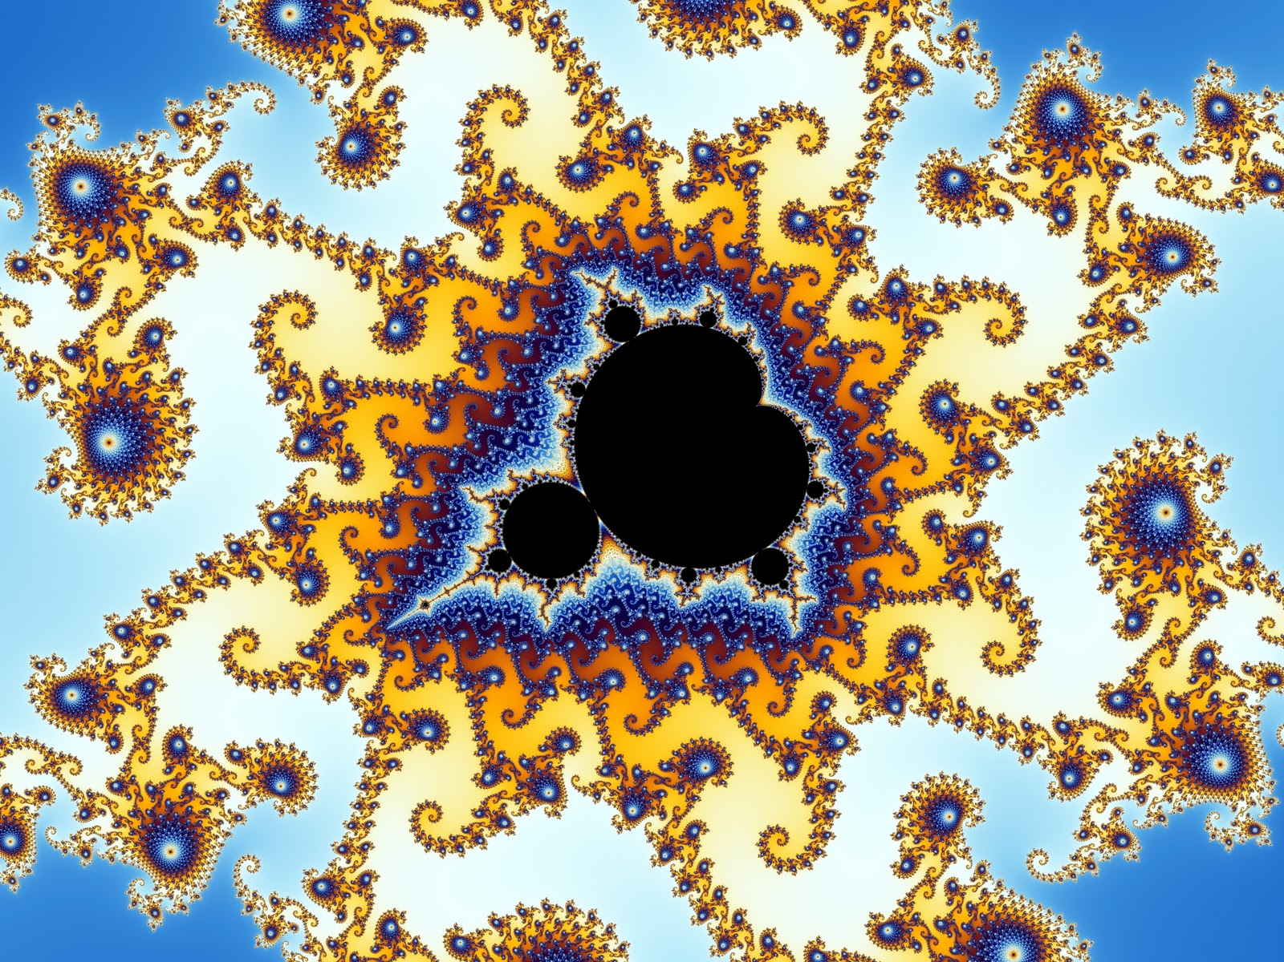

Sadly, Escher never met Mandlebrot. It is intriguing to speculate what art might arisen if they had.

*Escher and Penrose*

A second mathematician closely associated with Escher is Sir Roger Penrose OM, who was Gresham Professor of Geometry 1998-2001. Penrose is one of the worlds leading experts in general relativity, and has worked closely with Stephen Hawking. Penrose is the creator of the aperiodic tilings of the plane that we saw earlier. He is also associated (along with his father) in the creation of a set of ‘impossible objects’ two of which is illustrated below. These are called the Penrose triangle and the Penrose stairs, and they show how we can perceive an object to exist, even though it is mathematically impossible. The stairs are often called the ‘continuous staircase’ and seem to go ever upwards without limit.

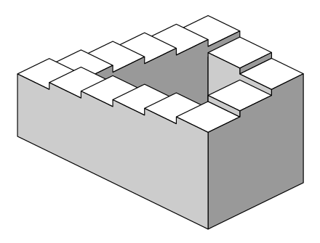

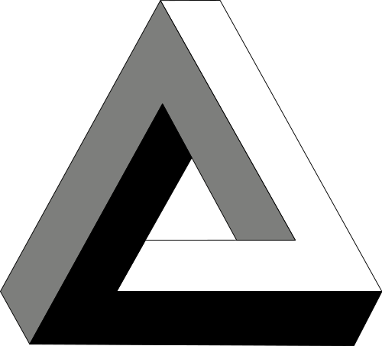

The "continuous staircase" was first presented in 1958 an article by Roger Penrose in the *British Journal of Psychology* in 1958. Escher discovered the Penrose stairs in the following year and made his now famous lithograph *Ascending and Descending* (below) in March 1960. Penrose and Escher were informed of each other's work that same year.Escher developed the theme further in his 1961 print *Waterfall*.

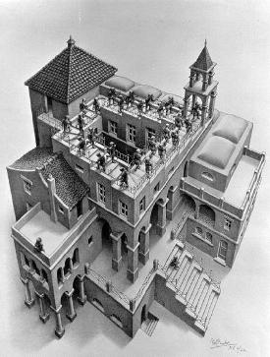

*Escher and Lenstra*

In 1956 the Escher made an unusual lithograph with the title Prentententoonstelling. It shows a man standing in an exhibition gallery, viewing a print of a Mediterranean seaport. What is remarkable about this picture is that we see simultaneously both the inside and the outside of the gallery. Escher used a mathematical approach to construct the picture, but he was unable to take it to completion, and the result was a blank circle in the middle. This picture is illustrated below.

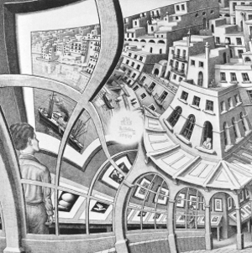

The immediate question on looking at this picture (once you have got over its striking visual form) is: what goes inside the hole?

Escher based his picture on the following grid:

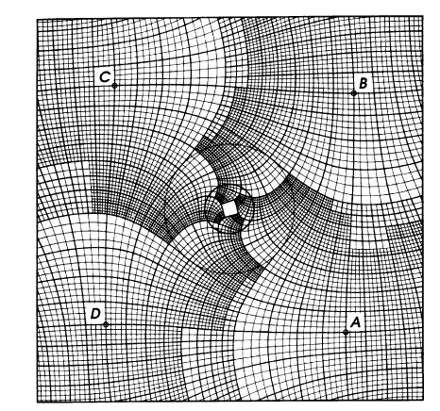

This grid has the property that as you travel from point A to D, the squares making up the grid expand by a factor of 4 in each direction. As you go clockwise around the center, the grid folds onto itself, but expanded by a factor of 256. Escher then started with a picture on a regular grid as shown below.

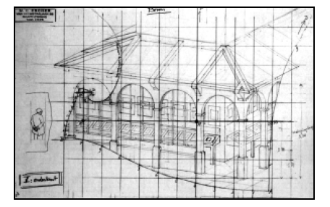

This was then mapped, square-by-square, onto the distorted grid to give the picture that Escher created. However his grid had a square in the middle which prevented him from completing the picture.

Not willing to see the picture incomplete, a group of Dutch mathematicians, led by Henrik Lenstra at the University of Leiden, determined a map in the complex plane which corresponded to Escher’s curved grid. By extrapolating this map backwards they could then also continue the picture backwards, and by doing so were able to fill in the hole. The result is presented below. If you look carefully you can see the image repeating itself an infinite number of times as it goes into the hole. Small wonder that Escher did not try to complete it!

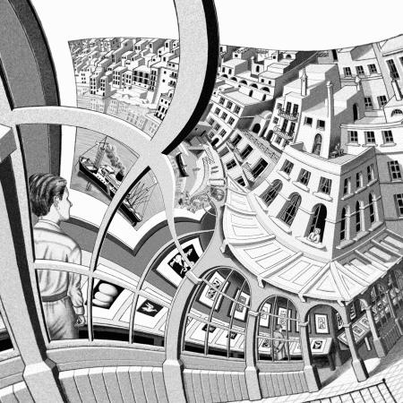

**6. Dancing with maths**

Dancing is a wonderful visual art form, and maths has much to say about it. Indeed, by using a bit of maths we can design some really great dances.

Dancing has many forms, from the elegance of the waltz to the energy of the Ceilidh, and from the beauty of the ballet to the anarchy of Morris dancing.

**References**

[1] Journal Article

[ ] D. Joyce, ( ?? ), The 17 plane symmetry groups David Joyce

https://www2.clarku.edu/faculty/djoyce/wallpaper/seventeen.html

# [ ] A. Bellos, (2015), *Muslim rule and compass: the magic of Islamic geometric design* https://www.theguardian.com/science/alexs-adventures-in-numberland/2015/feb/10/muslim-rule-and-compass-the-magic-of-islamic-geometric-design

# [ ] P. Gerdes, (1993), *Exploring Angolan Sand Drawings (sona): Stimulating Cultural Awareness in Mathematics Teachers ,*The Radical Teacher, University of Illinois Press, https://www.jstor.org/stable/20709758

[ ] https://en.wikipedia.org/wiki/Wallpaper_group

[ ] H. Lenstra, (2003), *Artful Mathematics: The Heritage of M. C. Escher,* Notices of the AMS

[ ] A. Bellos and E. Harris, ( ), Tilings

[ ] D. Hofstadter, (1979), *Gödel, Escher, Bach: an Eternal Golden Braid*

Chris Budd, March 2020